**Instituto Politécnico Nacional**

**Escuela Superior de Cómputo**

*Fundamental Analysis of Circuits*

Practice 9: Norton Theorem.

Group: 1CV13

Team: 7

Members:

Pastor Martínez Luis Enrique

Partido Terrón Luis Alberto

Pérez Garduño José Emiliano

Professor:

Raúl Santillán Luna

Practice day: November 27, 2017

Delivery day: December 4, 2017

**Index:**

1. Objective
2. Introduction
3. Development
4. Calculations
5. Conclusions

**Objective:**

* Apply the Norton theorem to analyze and solve the circuit.

**Introduction:**

*Thevenin Theorem:*

Thevenin theorem establishes the following: “Any DC current bilaterally lineal of two terminals can be replaced for a circuit equivalent that consists of a tension source and a resistor in series, as shown in the next figure.”

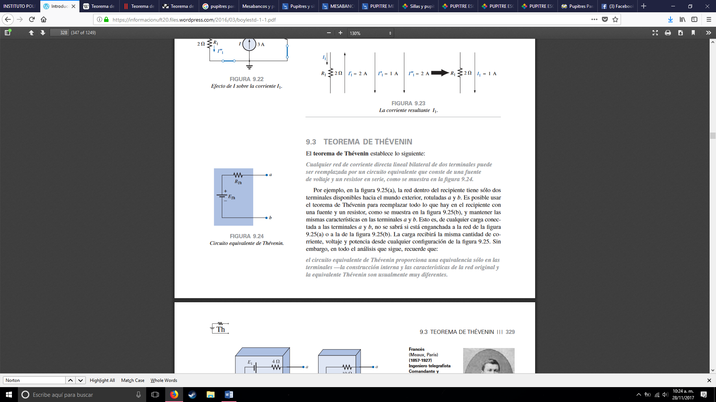

For example, in the next figure the current inside the recipient only has two terminals available for the outside world, named a and b. It´s possible to use Thevenin´s theorem to replace everything that´s in the recipient with a power supply and a resistor, as it´s shown, and maintaining the same characteristics it the a and b terminals. This is for every charge connected to terminals a and b, it won´t be known if it´s connected to the figure in the left or the right. The charge will receive the same quantity of current, tension and power from any configuration of the ones below. However, we must remember that: “The Thevenin equivalent circuit provides an equivalence only in the terminals – The intern construction and characteristics of the original network and the Thevenin equivalent are very distinct.”

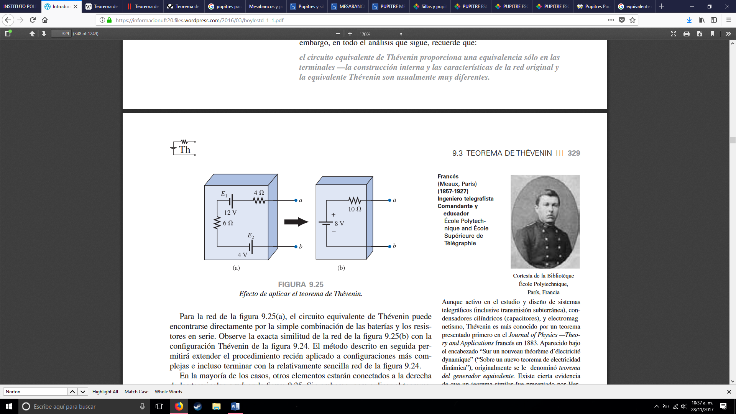

This theorem fulfills two very important objectives: First, as it was true for all the methods described before, it allows us to find any voltage or current particularly in a lineal network, with more than one current or voltage source. Second, it´s possible to concentrate over a specific portion of a network replacing the remaining circuit with a circuit equivalent.

*Norton Theorem:*

Norton theorem stablishes the following: “Any lineal bilateral DC network of two terminals can be replaced for an equivalent circuit that consists of a current source and a resistor in parallel” As it´s shown in the next figure.

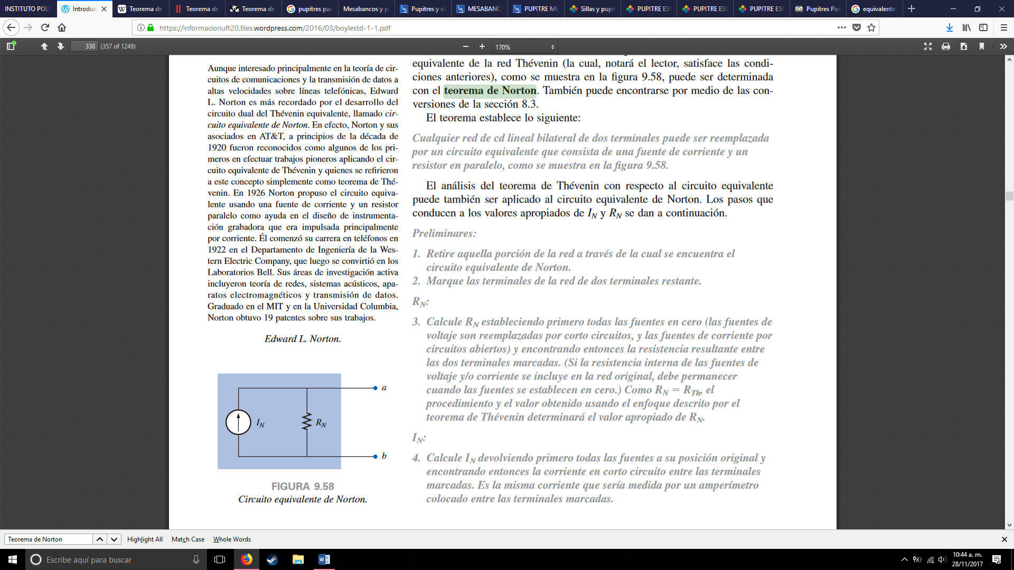

The steps to follow are the following:

1.- Retire that portion of the network in which it´s ubicated the Norton theorem equivalent.

2.- Mark each terminal of the two remaining networks.

*RN*

3.- Calculate *RN* establishing first all sources to 0 (The voltage sources are replaced by short circuit and the current sources are replaced by open circuits.) and finding then the resulting resistance between the two marked terminals. (If the intern resistance is of the tension and current sources are included in the original network, it must remain when the sources are set to 0.) As RN = R*TH* the development and value obtained using the focus described by the Thevenin theorem it will determine the appropriated value for RN.

IN

4.- Calculate IN returning first all sources to their original position and finding then the current in short circuit between the marked terminals. It´s the same current that would be measured by an amperemeter collocated between the two terminals.

5.-Trace the Norton equivalent circuit in the portion of the circuit previously removed, replace between the terminals of the equivalent circuit.

The Norton and Thevenin circuits equivalents can also be found from one or another using the source transform theorem.

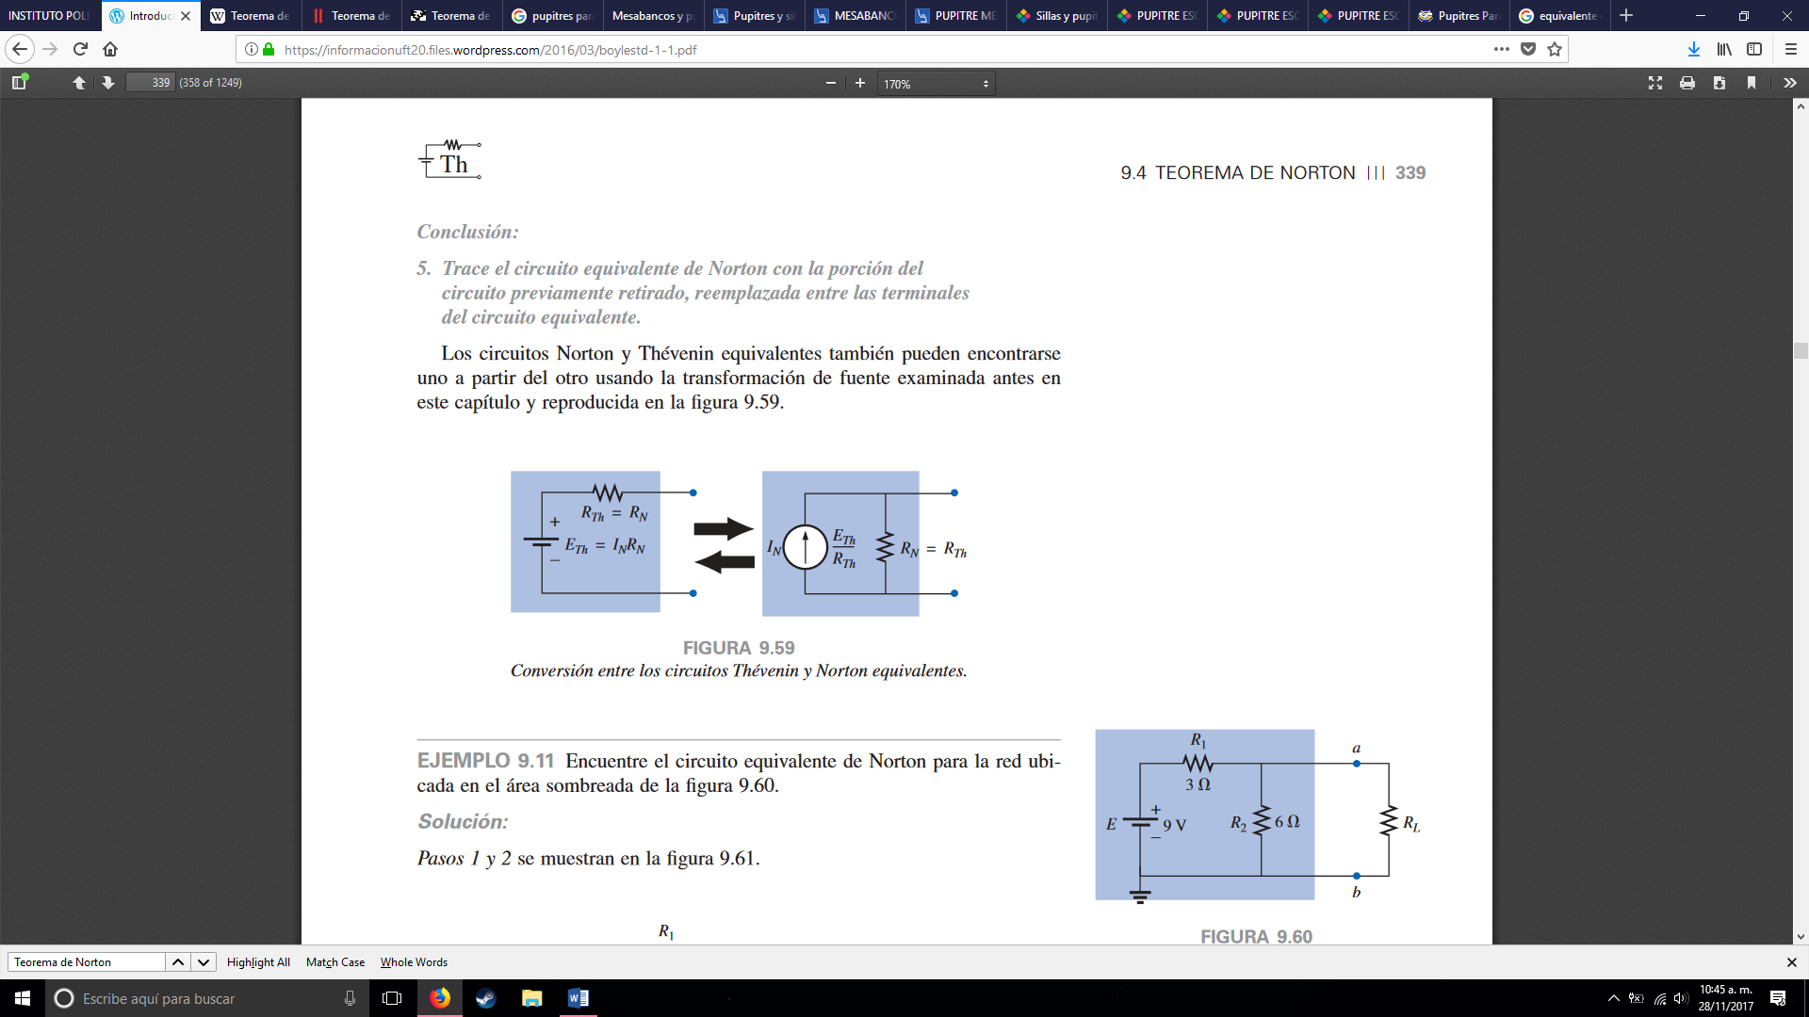

**Development:**

Before going to the laboratory, the student must obtain the values requested in table 1, taking as reference the circuit of figure 1 and applying Norton theorem seen in class. Besides, he will make the simulation of each circuit using some software tool and he will include that in his report with the mathematical development with the recommended analysis.

1.- Without turning on the power supplies, arm the circuit shown in figure 1.

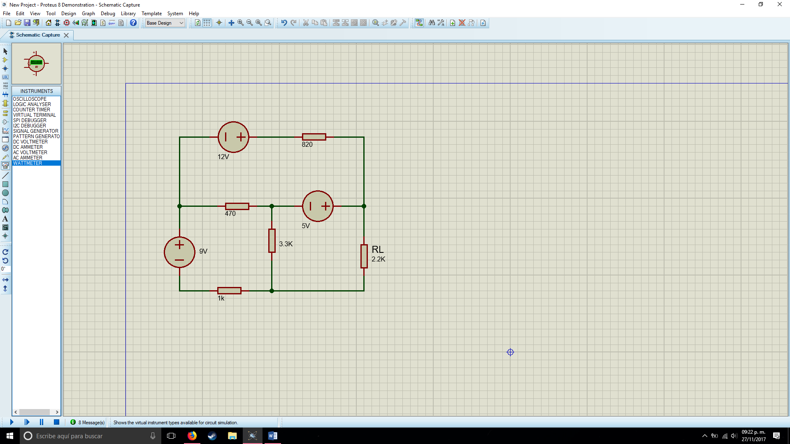

2.- With the circuit already armed, turn on the power supplies and measure the values requested in table 1.

|  |  |  |  |
| --- | --- | --- | --- |
| Measurements | Theoretical value. | Value measured. | Simulated value. |
| IL | 4.25 mA | 4.38 mA | 4.24 mA |
| VL | 9.3 V | 9.17 V | 9.33 V |
| PL | 39.525 mW | 40.16 mW | 39.55 mW |

3.-Turn off the supplies and disconnect the RL resistor. Then proceed and make the measurements indicated in table 2 and how it´s shown in figures 2 and 3, the voltage in the open circuit and current to short circuit between the nodes A and B.

|  |
| --- |
| Simulations |
|  |
|  |
|  |

|  |  |  |  |
| --- | --- | --- | --- |
| Measurements | Theoretical Value | Measured Value | Simulated Value |
| IAB = IN | 6.33mA | 6.77 mA | 6.34 mA |
| VAB = VTH | 13 V | 12.87 V | 13.3 V |
| RN = = | 2053.71Ω | 1901.03Ω | 2097.79 Ω |

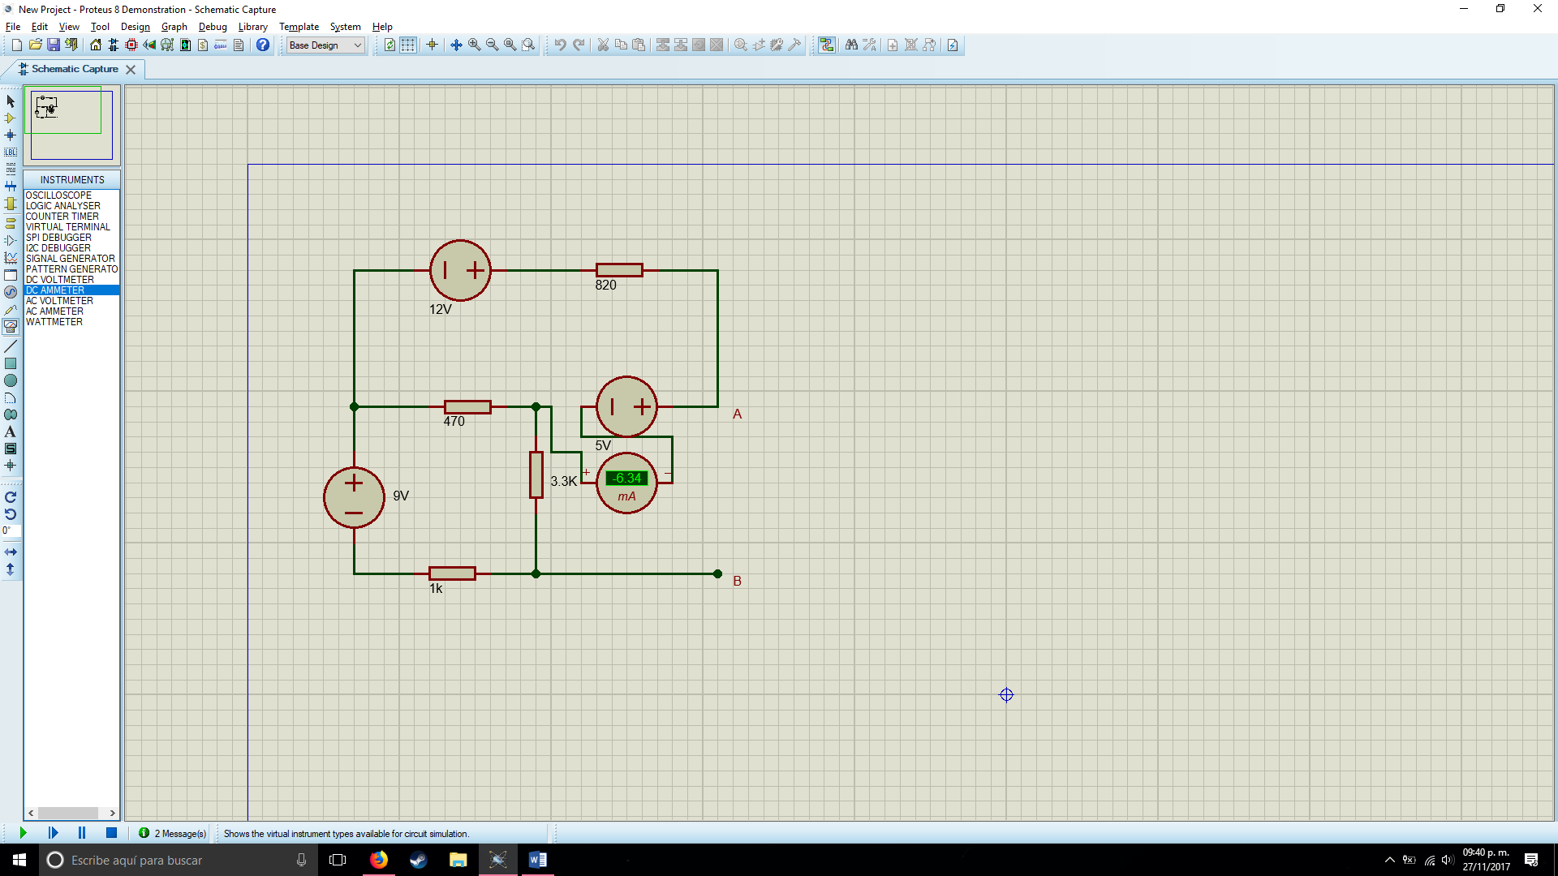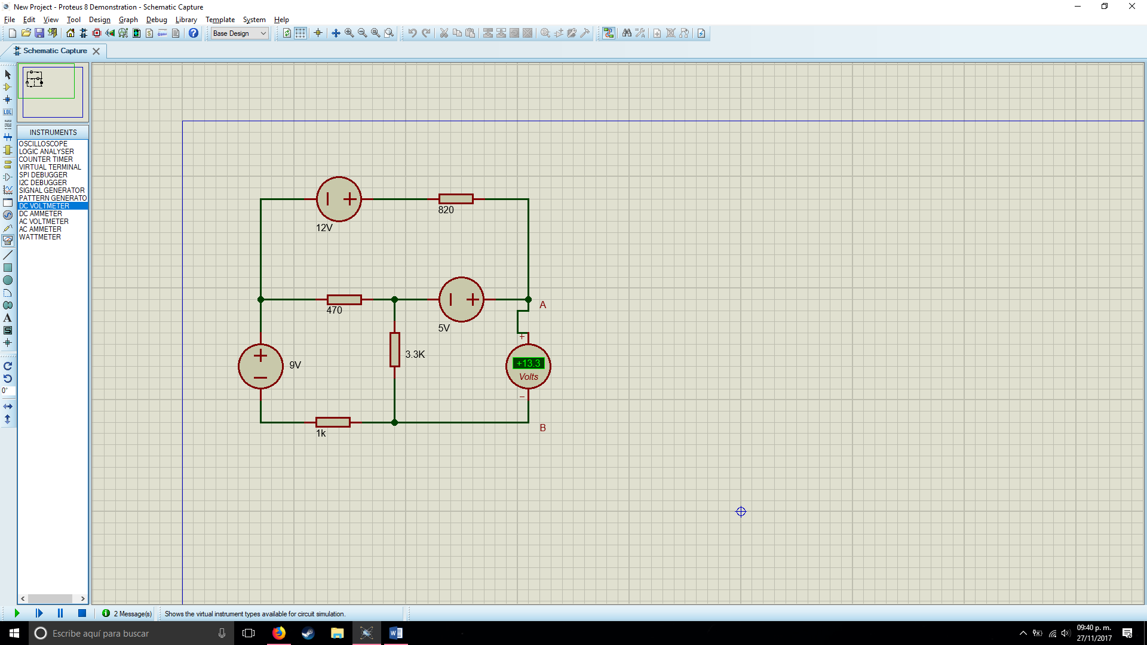

4.- With the last measurements obtain the same resistance of Norton and proceed to constructing the equivalent circuit of Norton, like it´s shown in figure 4 and will help of a software tool for circuit simulation, placing the RN and the power supply of Norton with the experimental value obtained in the last point. Then realize the measurements asked in table 3.

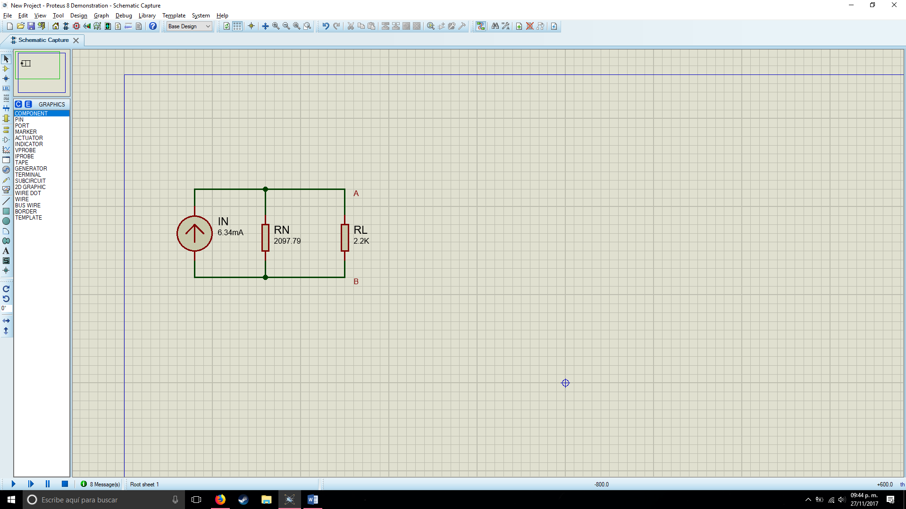

|  |  |  |  |
| --- | --- | --- | --- |
| Measurements | Theoretical Value | Measured Value | Simulated Value |
| IL | 3.1 mA | 3.045mA | 3.09 mA |
| VL | 6.82 V | 6.8 V | 6.81 V |
| PL | 21.14 mW | 20.70 mW | 21.04 mW |

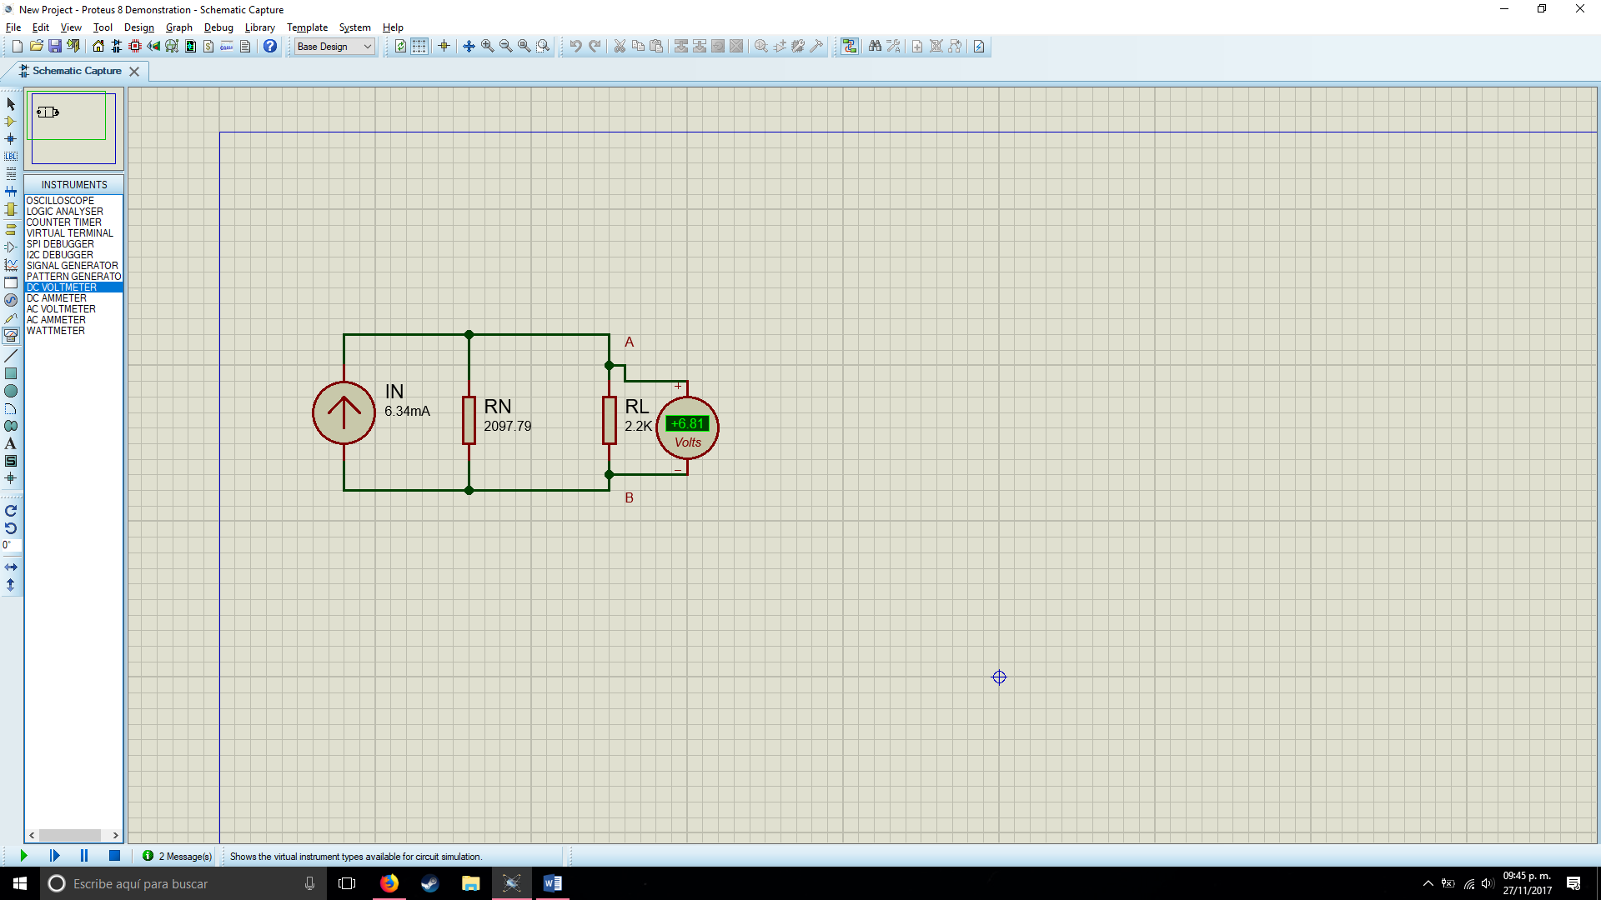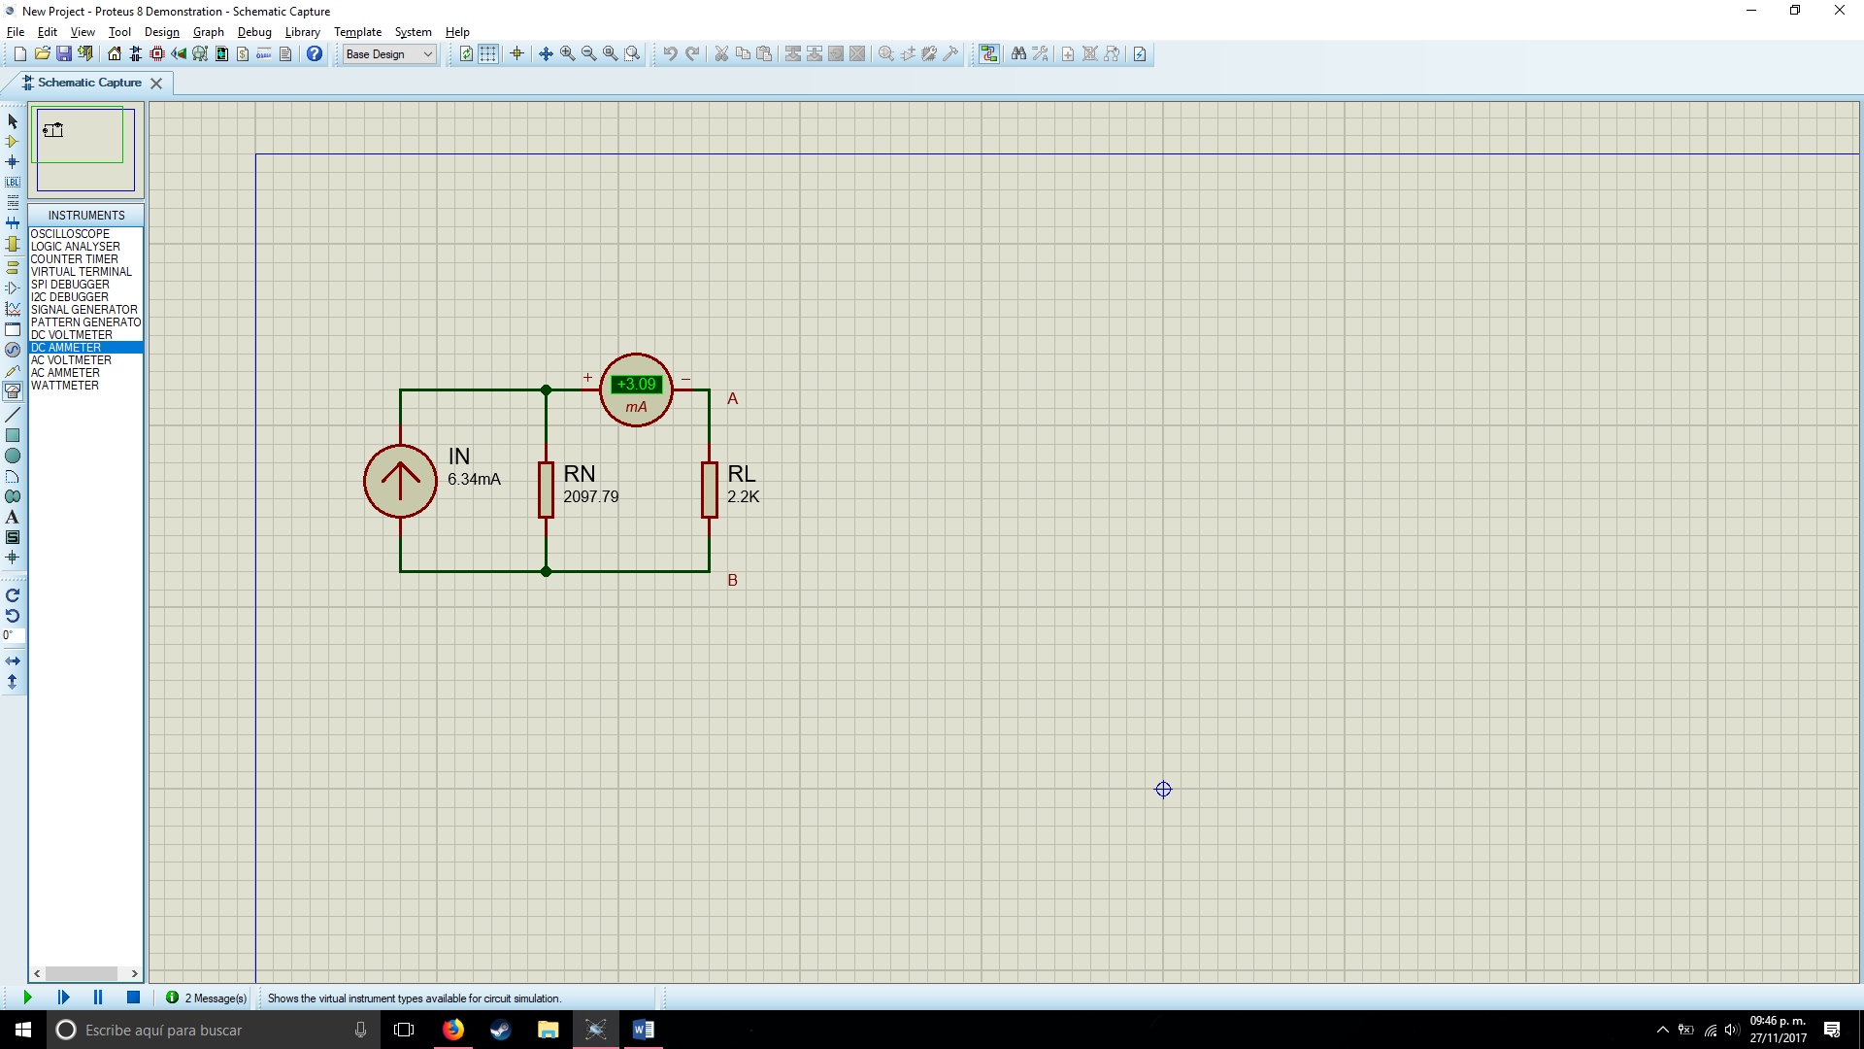

5.- Compare your results of point 4 with the ones obtained in point 2, the ones which were registered in table 1, and write your commentaries.

**Questioner:**

1.- What does the Norton Theorem establishes?

R= Norton’s theorem states that any linear complex electrical circuit can be reduced into a simple electric circuit with one current and resistance connected in parallel.

2.- With what end it was measured the voltage at open circuit and the current in short circuit between the points A and B in the point 3 of the development?

R= So that we can reduce it to a much smaller circuit and it can become more manageable.

3.- Is there any difference between the RN calculated theoretically than the ones measured? Why?

R=Yes, a little bit of the value seems off, apparently due to the fact that the elements we work with aren´t perfect.

4.- What is the utility of the Norton Theorem in the circuit theory?

R= It´s normally used to reduce circuits to a much simpler one, implying only one resistor in series or parallel.

**Conclusions:**

Luis Enrique:

Luis Alberto:

José Emiliano: We had some complications while measuring the values when removing the resistor from the circuit, since it was giving us values way to high for the practice, so we had to arm the circuit again verifying every part to make sure that it wasn´t disconnected or being placed in a different place, but we got different values than the ones we needed, but in the end, we got it.

***Bibliography:***

Boylestad, Robert L. Análisis Introductorio de Circuitos. Prentice Hall. México 1998, 1168 pags.

<https://informacionuft20.files.wordpress.com/2016/03/boylestd-1-1.pdf>